Who participated:

Brandon George, Noah Lindsey, Mitch Whedon, Tim Ours, Adam Hursey, Chris Arpin

Prioritized Lists of Customer Requirements:

* Be able to apply a charge per transaction
* User be able to set up an account with validated email
* User is able to put items for sale
* Seller can easily upload an item to sell/trade
* Item is posted for one week by default
  + Listing is set to expire in one week by default, can be changed by user depending on item being sold
* Record of Buying and Selling
  + Users will be able to access a purchase/selling history for taxation purposes
* Buyers and Sellers are able to offer/accept trades (NO BARTERING)
* Buyer may specify quantity of item to buy
* Buyer can look at items without setting up an account
  + Unregistered users can only view listings, need to register to buy items
* Stream is the home page
  + The home page is the feed of items being sold, in chronological order with the newest listings at the top
* Simple layout/design according to Material Design standards
  + Easy to see colors and easy to navigate layout

**Minor Requirements**

* Buyers and Sellers have to ability to message within the app
* User has ability to leave rating on sellers/produce
* Search by Keyword
* Set the distance where they can only be seen for 25 miles away
* Apply for a refund
* Option to toggle between closeness and proximity
* Report users
* Ability to tag a friend
* Search by tags (ie. Organic/No Spray)

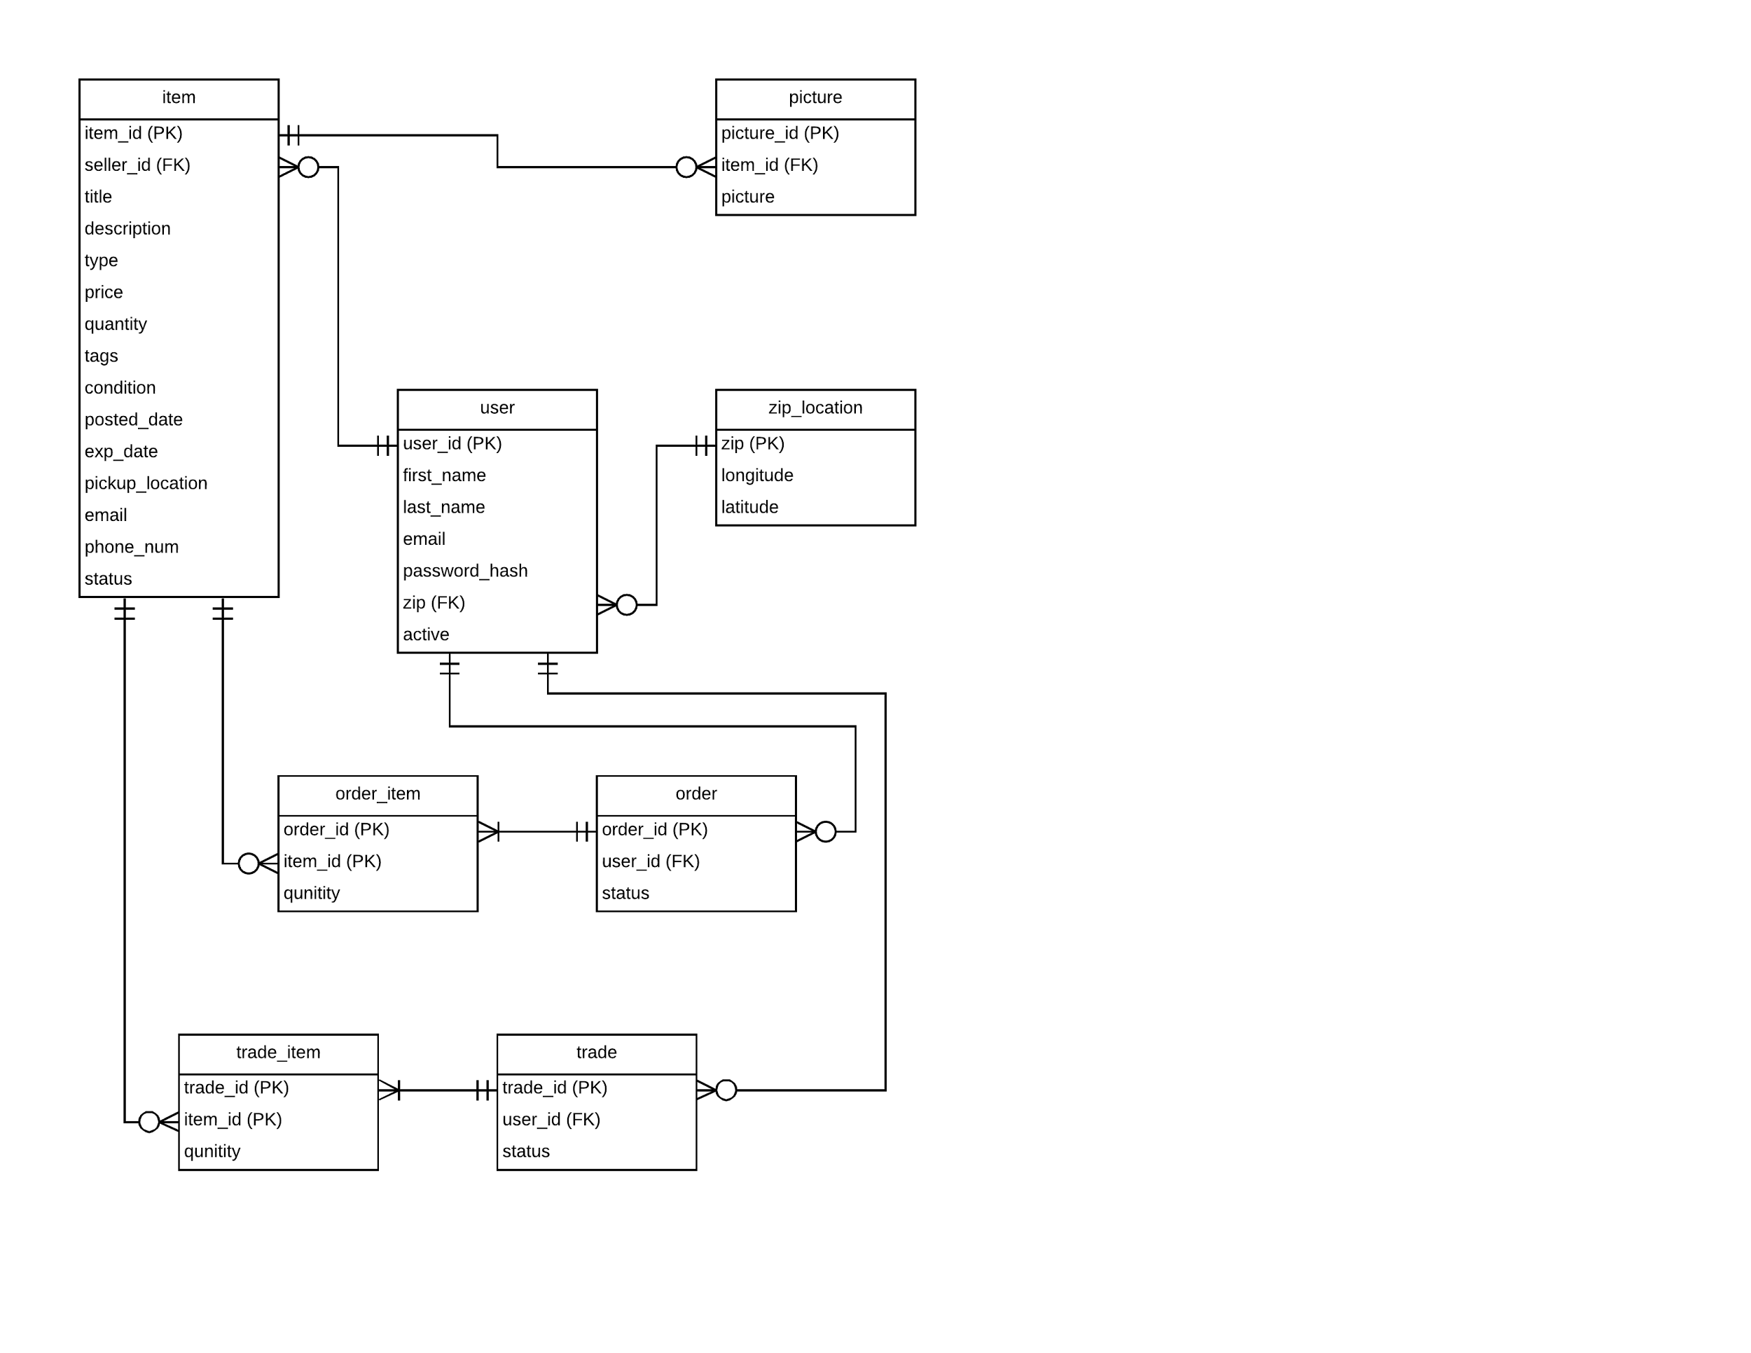

|  |  |  |  |  |  |
| --- | --- | --- | --- | --- | --- |
| **Event ID** | **Source** | **Trigger** | **Response** | **Major Outputs** | **External Destinations** |
| L1 | Customer | Enters the app | Shows a list of items within 25 miles | Home feed | None |
| L2 | Customer | Presses the account button | Shows login page | Login page | None |
| L3 | Customer | Login to user account | Validation from the server | 1. User logged in  2. Error | None |
| L4 | Customer | Selects to create an account | Creates a form to allowed to enter user information | 1. New account sent into the home feed  2. Error | Project database |
| L5 | Customer | Submitting the create account form | Sent to the server for validation | 1. User added to the database and sent to the home feed  2. Error | Project database |
| L6 | Customer | Selects to delete an account | Server asks if customer is certain that they want their account information removed | Updates account status to “inactive” | Project database |
| L7 | Customer | Updating user account | Updates the information in the user profile | 1. Update for account row  2. Error | Project database |
| L8 | Customer | Pressing the Distance Button | Pop up box where customer can edit the distance that the app looks for items | Changes searching distance to the set amount | None |
| C1 | Customer | Enters a quantity | Calculates price | Price | None |
| C2 | Customer | Buys items | Adds an order to the database and notifies the seller | Order data, Email to seller | Project database, seller email |
| C3 | Customer | Presses home button | Customer sent to the home feed | Home feed | None |
| C4 | Customer | Views the details of a listing | Generates page with more information about the item | Item page | None |
| T1 | Customer | Offers Trade | Adds a trade to the database | Trade data | Project database |
| T2 | Seller | Accepted Trade | Update trade data to close trade and email offering customer | Trade data, email to offering customer | Project database, offering customer email |
| S1 | Seller | Lists an item for sale | Adds new listing to database | Listing data | Project database |
| S2 | Seller | Change time that listing is for sale | Updates expiration date of listing | Listing time updated | Project database |
| S3 | Seller | Remove listing | Sets listing to inactive | Listing data | Project database |
| S4 | Seller | Wants to post item | Sent to form for listing | Form created and displayed | None |
| S5 | Seller | Clicks button to view trade offers | Sent to trade offers page | Trade offers page | None |
| S6 | Seller | Clicks on button to view account listings | Sent to account listings page | Account listings page | None |
| S7 | Seller | Clicks to edit listing | Sent to update listing page | Update listing page | None |
| S8 | Seller | Confirms updates to listing | Updates listing in database | Listing data | Project database |